

11/30/2024

Amogh CG

CN Enterprises

Online order

Flipkart

**Introduction:**

Flipkart is one of India's leading e-commerce platforms, founded in 2007 by Sachin and Binny Bansal. Originally an online bookstore, it now offers a vast range of products, including electronics and fashion. The platform is known for exclusive sales events like "Big Billion Days" and features like Flipkart Plus, which enhances customer loyalty. It operates as a marketplace, allowing third-party sellers to list products, and utilizes advanced technologies for personalized user experiences. Flipkart's acquisition by Walmart in 2018 has further strengthened its market position. It has significantly influenced the Indian e-commerce landscape by promoting digital payments and altering consumer shopping habits.

**Preface:**

Welcome to the world of Flipkart, where your shopping experience transforms into a delightful journey! Established in 2007, Flipkart has grown from a humble startup to one of India’s leading e-commerce platforms, empowering millions of customers with access to an extensive range of products right at their fingertips. Our mission has always been to make online shopping simple, enjoyable, and accessible to everyone, regardless of their geographical location.

In this digital age, where convenience meets choice, Flipkart stands at the forefront, offering everything from electronics and fashion to home essentials and beyond. Our commitment to innovation drives us to continuously enhance our platform, ensuring a seamless shopping experience with user-friendly navigation, secure payment options, and efficient delivery services.

But beyond the technology and logistics, Flipkart is about you – our valued customers. Your trust and loyalty inspire us to set new benchmarks in customer service. We believe in understanding your needs and preferences, which is why we offer personalized recommendations and exclusive deals tailored just for you.

As we embark on this exciting journey together, we invite you to explore the vast marketplace we have created. Whether you are a tech enthusiast, a fashionista, or someone looking to spruce up their home, we have something for everyone. Join us in celebrating the joy of discovering new products and connecting with the global community of shoppers.

Thank you for choosing Flipkart as your preferred shopping destination. We look forward to serving you and making every shopping experience memorable!

Happy Shopping!

Contents

Step 1: Create an Account 3

1. Visit the Flipkart Website or App 3

2. Sign Up 3

Step 2: Browse Products 4

1. Search for Items 4

2. Filter and Sort Results 5

Step 3: Add to Cart 5

1. Check Product Details 5

2. Add to Cart 5

Step 4: Review Your Cart 6

1. Access Your Cart 6

2. Modify Your Cart 6

Step 5: Place Your Order 6

1. Login to Your Account 6

2. Enter Shipping Details 6

Step 6: Order Confirmation 7

1. Receive Confirmation 7

2. Track Your Order 7

- Delivery 7

- Unboxing and Inspection 7

Conclusion 8

# Step 1: Create an Account

## 1. Visit the Flipkart Website or App

Open your web browser and go to [Flipkart](https://www.flipkart.com/) or download the Flipkart app from the App Store or Google Play Store or Click [here](http://www.flipkart.com) .

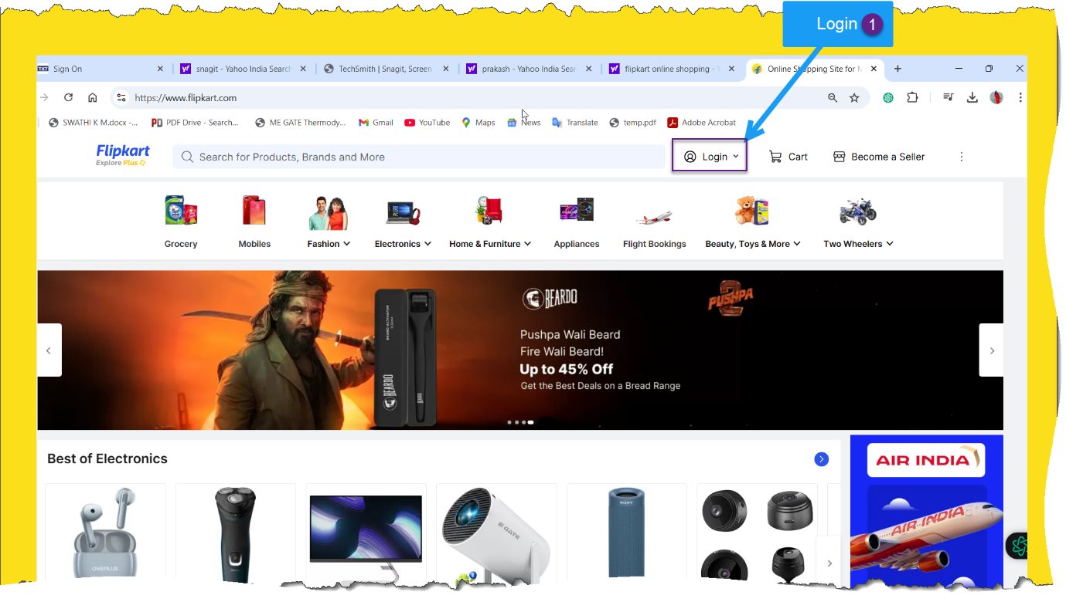

### 2. Sign Up

If you are a new user, click on the “Login” button at the top right corner.

Select “New to Flipkart? Create an account” and fill in the required details, such as your name, mobile number, and email address.

Create a password and agree to the terms and conditions.

Click “Continue” to complete the registration process.

#### 3. Verify Your Account

You may be asked to verify your mobile number or email address through an OTP (One Time Password).

# Step 2: Browse Products

## 1. Search for Items

Use the search bar at the top of the page to type in the name of the product you want to buy.

Press Enter or click the search icon to see the results.

### 2. Filter and Sort Results

Utilize the filtering options on the left sidebar (example category, brand, price range) to narrow down your search.

Sort the results by relevance, price, or discounts using the sort option at the top.

#### 3. Select a Product

Click on a product to view its details, including price, specifications, and customer reviews.

# Step 3: Add to Cart

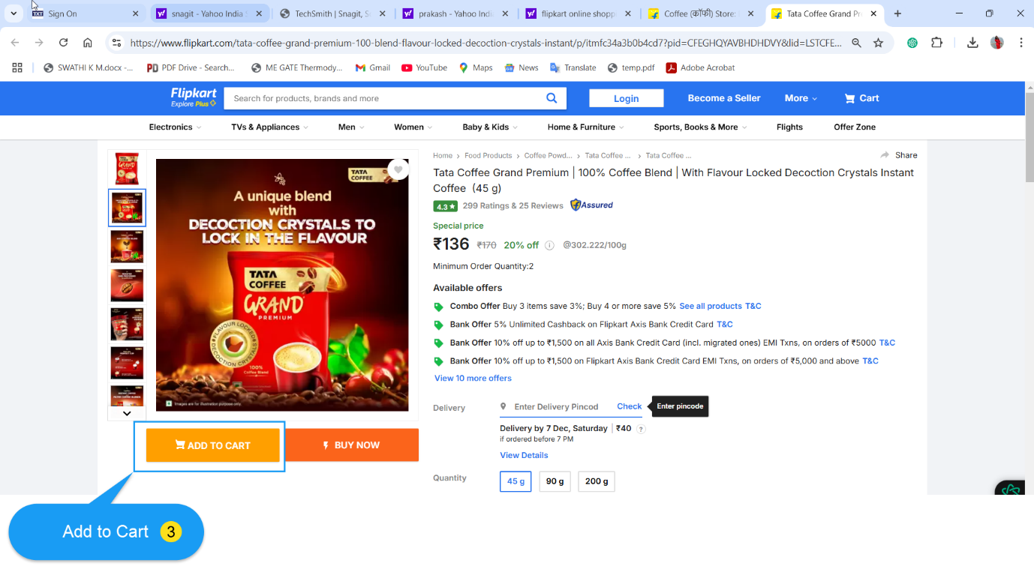

## 1. Check Product Details

Review the product’s features, specifications, and available offers.

Make sure to select the desired size, colour, or quantity if applicable.

### 2. Add to Cart

Click the “Add to Cart” button to save the item for later purchase.

A pop-up will appear confirming that the item has been added to your cart.

# Step 4: Review Your Cart

## 1. Access Your Cart

Click on the cart icon in the top right corner of the page to view all items you have added.

### 2. Modify Your Cart

You can update quantities, remove items, or continue shopping if you need to add more products.

#### 3. Proceed to Checkout

When you are ready to purchase, click the “Checkout” button.

# Step 5: Place Your Order

# 

## 1. Login to Your Account

If prompted, enter your login credentials.

### 2. Enter Shipping Details

Fill in your delivery address, including your name, mobile number, and complete address. Make sure your address is accurate for timely delivery.

#### 3. Choose Payment Method

Select your preferred payment method from the available options: debit/credit card, net banking, UPI (Unified Payments Interface), or cash on delivery (COD).

If using an online payment method, enter the required details.

##### 4. Apply Coupons

If you have any discount codes, enter them in the appropriate field to avail discounts.

###### 5. Review Order Summary

Check the order summary for the product details, total price, and shipping costs.

6. Place Order

Click on the “Place Order” button to complete your purchase.

# Step 6: Order Confirmation

## Receive Confirmation

You will receive an order confirmation email or SMS containing your order number and details.

### Track Your Order

You can track your order status by going to the “My Orders” section in your account.

#### Step 7: Receive Your Product

## Delivery

Your product will be delivered to the address provided within the estimated delivery time.

### Unboxing and Inspection

After receiving the product, inspect it for any damage and ensure it matches your order. If there are any issues, you can initiate a return or replacement process through the Flipkart app or website.

# Conclusion

Ordering online from Flipkart is a straightforward process that involves browsing items, adding them to your cart, and placing an order. Follow these steps, and you will be well on your way to enjoying the convenience of online shopping. Happy shopping!

